Preparing the Camera Ready Paper for the Conference InfoTech-2024

Stefan Jordanov Ovcharov and Katya Konstantinova Asparuhova
Department of Electronics, Faculty of Electronic Engineering and Technologies
Technical University of Sofia
8, Kliment Ohridski blvd., 1000 Sofia, Bulgaria
{sjo, k_asparuhova}@tu-sofia.bg

Abstract – These instructions give you basic guidelines for preparing conference papers. The recommended text processor must be not older than Microsoft Word 2007. The abstract is a brief (50-80 words) synopsis of the paper. Use up to 5 keywords.
Keywords – component; formatting; style; styling; insert (key words); up to five, in alphabetical order.

I. Introduction

This TEMPLATE must be used for preparation of an article Type [1] which will be proposed for publishing in edition with possible indexing in Scopus (in the Infotech-2023 Proceedings will be published the abstract ONLY). The submitted version in MS Word format must not exceed 4 pages (8 pages for Invited Papers), including all tables, figures and references. Please, contact organizers if you have questions

A. Layout

In formatting your A4-size paper (210x297mm), set the margins as given in table 1. Manuscript have to be prepared in two columns separated by 5 mm.

Table 1. Page Layout Description

Top margin | 2.5cm
Bottom margin | 2cm
Left margin | 2cm
Right margin | 1.5cm
Column spacing | 0.5cm

B. Fonts, Sectioning, Figures and Tables

Times New Roman 10 point font should be used for normal text. Try to follow the font sizes specified in Table 2, as best you can. Note: authors' affiliations (institution, address and e-mail) should be given in the bottom of the first column using 9pt font. Please do not write telephone and fax number.
Figures and tables should be one column wide. In some rare cases it is allowed to use two columns wide figures and tables located at the top or at the bottom of the page.
All half-tone illustrations (pictures/photographs) should be clear black and white prints. Figure format *.bmp, pictures/photograph format - *.jpg.

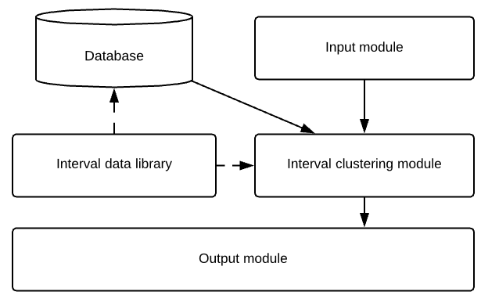
Fig. 1. Example of a figure
Try to place the figures and tables after their first mention in the text.

Table 2. Font Sizes

Font  Size | Bold | Italic | Text
22 | YES |  | Paper title – Centered
14 |  |  | Authors’ full names – Centered, Spacing before 6pt
9 |  |  | Authors’ affiliations
9 | Yes |  | Abstract and keywords
10 |  |  | Main text in two columns
12  Small  Caps |  |  | Sections (Introduction,Con- clusion, References etc.) - centered
10 |  | Yes | Subsection - Left
10  Small  Caps |  |  | References
9 |  |  | Text in the references
9  Small  Caps |  |  | Table names - centered
9 |  |  | Table text
9 |  |  | Figure captions - centered

C. Equations

Equations should be centered and labelled consecutively with equation numbers in parentheses flush with the right margin. The example of equations is Eq. 1:

(1)

II. Conclusion

The instructions for preparing of camera ready papers for the conference InfoTech are given.

Acknowledgment

The preferred spelling of the word “acknowledgment” in America is without an “e” after the “g.” Avoid the stilted expression “one of us (R. B. G.) thanks ...”. Instead, try “R. B. G. thanks...”. Put sponsor acknowledgments in the unnumbered footnote on the first page.

References

[1] G. Eason, B. Noble, and I.N. Sneddon, “On certain integrals of Lipschitz-Hankel type involving products of Bessel functions,” Phil. Trans. Roy. Soc. London, vol. A247, pp. 529-551, April 1955. (references)
[2] J. Clerk Maxwell, A Treatise on Electricity and Magnetism, 3rd ed., vol. 2. Oxford: Clarendon, 1892, pp.68-73.
[3] I.S. Jacobs and C.P. Bean, “Fine particles, thin films and exchange anisotropy,” in Magnetism, vol. III, G.T. Rado and H. Suhl, Eds. New York: Academic, 1963, pp. 271-350.
[4] K. Elissa, “Title of paper if known,” unpublished.
[5] R. Nicole, “Title of paper with only first word capitalized,” J. Name Stand. Abbrev., in press.
[6] Y. Yorozu, M. Hirano, K. Oka, and Y. Tagawa, “Electron spectroscopy studies on magneto-optical media and plastic substrate interface,” IEEE Transl. J. Magn. Japan, vol. 2, pp. 740-741, August 1987 [Digests 9th Annual Conf. Magnetics Japan, p. 301, 1982].
[7] M. Young, The Technical Writer’s Handbook. Mill Valley, CA: University Science, 1989.

